GOVERNMENT ARTS AND SCIENCE COLLEGE, ALANGUDI

Department of computer science

INTERNSHIP REPORT

ON

**COOKBOOK**:YOUR VIRTUAL KITCHEN ASSISTANT

# (REACT APPLICATION)

# Virtual Internship Program Organized by SMART INTERNZ

**Submitted by :**

|  |  |
| --- | --- |
| Team ID | NM2025TMID35242 |
| Team size | **4** |
| Team Leader | **SANTHIYA S** |
| Team member | **HEMAJANANI M** |
| Team member | **JEEVASRI R** |
| Team member | **MAHASREE T** |

**INTRODUCTION:**

CookBook: Your Virtual KitchenAssistant is your ultimate digital cooking companion, designed to simplify meal planning and enhance your culinary experience. Whether you're searching for new recipes, organizing your favorite dishes, or discovering personalizedmealsuggestions,CookBookmakescookingeasierandmoreenjoyable.Withan intuitive interface, step-by-step instructions, and smart ingredient management, this Reactpowered app ensures that every meal is a success. From beginner cooks to seasoned chefs,

CookBookis hereto inspireandassist you inthekitchen—onerecipeatatime!

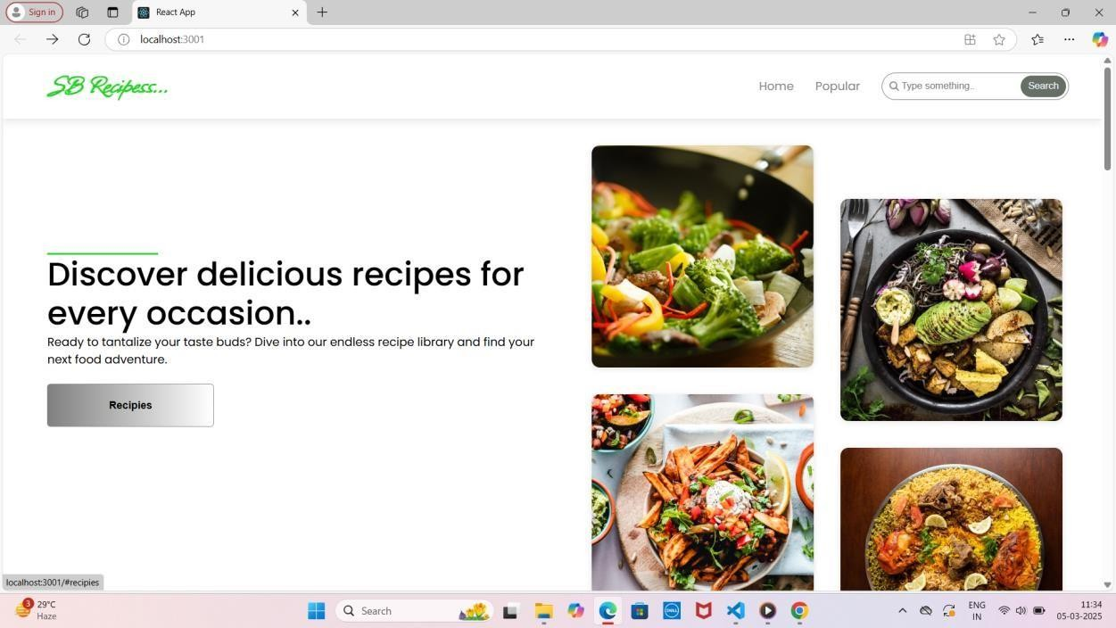

### Description:

CookBook is a React-based web application designed to make cooking effortless and enjoyable.Itallowsuserstoexploreavastcollectionofrecipes,savetheirfavoritedishes,and organize ingredients efficiently. With smart search functionality, step-by-step cooking instructions,andpersonalizedmealrecommendations,CookBookcaterstobothbeginnersand experienced chefs. The app also features an intuitive user interface, meal-planning tools, and grocery list integration to streamline the cooking process. Whether you're looking for quick weeknight dinners or gourmet creations, Cook Book is your perfect kitchen companion.

Beyondjustarecipemanager,CookBookofferssmartfeatureslikepersonalizedmeal recommendations,ingredientsubstitutions,andgrocery listgeneration.Theapphelpsusers optimizetheirkitchenexperiencebysuggestingmealsbasedonavailableingredients,dietary preferences,and cookingtime.With built-in searchfunctionality and filteroptions,findingthe perfect recipe is quick and hassle-free.

CookBookisdesignedtobeaseamlessandinteractivecookingassistantforusersofall skilllevels.Itsresponsivedesignensuresaccessibilityacrossdevices,allowinguserstobrowse andfollowrecipesfromtheirdesktop,tablet,ormobilephone.Whetherplanningmealsforthe week or trying out a new dish, CookBook is your go-to kitchen companion, making cooking more enjoyable, efficient, and stress-free.

From hearty breakfasts to indulgent desserts, each recipe is crafted with love, using simpleingredientsthatbringpeopletogether.Withstep-by-stepinstructions,cookingtips,and vibrant photos, *Flavors of Home* makes it easy to create unforgettable meals for family and friends.

Cooking is more than just preparing food—it’s an experience that brings people together. *The Ultimate Cookbook* is your go-to guide for creating mouthwatering meals, whether you're cooking for a cozy family dinner or a festive gathering. With a diverse collection of recipes ranging from quick and easy weekday meals to impressive dishes for special occasions, this book is designed to inspire both beginners and seasoned cooks alike. Eachrecipeiscarefullycraftedwithsimpleingredients,step-by-stepinstructions,andhelpful tips to ensure success in the kitchen.

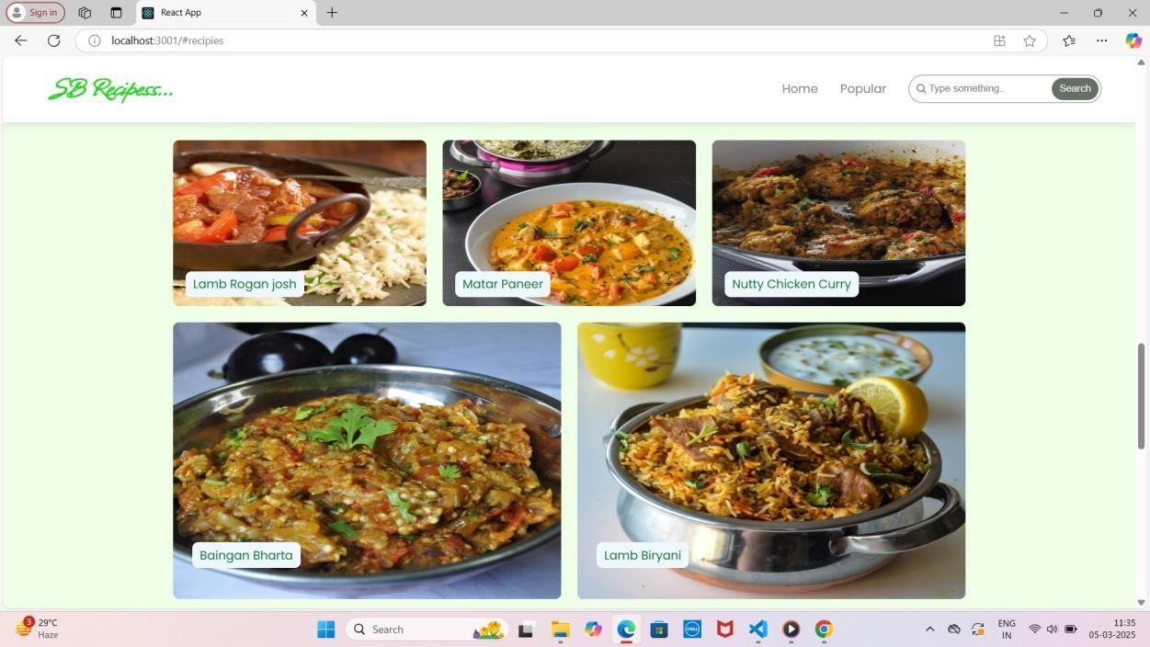

## SCENARIO:ABusyProfessionalPlanningaHealthyDinner

Emma is a busy marketing executive who loves cooking but struggles to plan meals after long work hours. One evening, she opens **CookBook:YourVirtual KitchenAssistant** on herphone, looking foraquick and healthy dinneridea. Sheuses the **smartsearch feature** tofilterrecipesby“under30minutes”and“high-protein.”Withinseconds,shefindsa**grilled salmon with quinoa salad** recipe that fits her preferences.

Beforeheadingtothekitchen,Emmachecksherpantryandrealizesshe’soutofquinoa. Luckily, Cook Book suggests **alternative ingredients**, recommending brown rice as a substitute. She updates her grocery list within the app and makes a mental note to pick up quinoa on her next shopping trip.As she cooks, she follows the **step-by-step instructions** on her tablet, using the app’s built-in **timer and measurement converter** to ensure accuracy.

After enjoying her delicious meal, Emma saves the recipe to her “Quick & Healthy” collection for future reference. She also rates the dish and leaves a note about adding extra lemon juice for more flavor. Thanks to CookBook, Emma has not only prepared a nutritious meal with ease but has also streamlined her meal-planning process—making healthy eating more convenient despite her busy schedule.

# TECHNICALARCHITECTURE:

The user experience starts with the CookBooks web application's UI, likely built with a frameworklikeReactorVue.jsforasmooth,single-pageexperience.ThisUIinteractswithan API client specifically designed for CookBooks. This client handles communication with the backend, but with a twist: it leverages Rapid API, a platform providing access to various externalAPIs.This suggests CookBooks might integrate external data feeds or functionalities through RapidAPI, enriching the user experience without building everything from scratch.

PRE-REQUISITES:Herearethekeyprerequisitesfordevelopingafrontendapplicationusing React.js:✓Node.jsandnpm:Node.jsisapowerfulJavaScriptruntimeenvironmentthatallows you to run JavaScript code on the local environment. It provides a scalable and efficient platform for building network applications. Install Node.js and npm on your development machine, as they are required to run JavaScript on the server-side. • Download: https://nodejs.org/en/download/ • Installation instructions: https://nodejs.org/en/download/package-manager/ ✓React.js: React.jsis a popularJavaScript library for building user interfaces. It enables developers to create interactive and reusable UI components, making it easier to build dynamic and responsive web applications. Install React.js,aJavaScriptlibraryforbuildinguserinterfaces.•CreateanewReactapp:npxcreate- react-appmy-react-appReplacemy-react-appwith yourpreferredprojectname.•Navigateto the project directory: cd my-react-app • Running the ReactApp: With the React app created, you can now start the development server and see your React application in action. • Start the development server: npm start This command launches the development server, and you can access your React app at [http://localhost:3000](http://localhost:3000/) in your web browser. ✓ HTML, CSS, and JavaScript: BasicknowledgeofHTMLforcreating thestructureofyourapp, CSSforstyling, and JavaScript for client-side interactivity is essential. ✓ Development Environment: Choose a code editor or Integrated Development Environment (IDE) that suits your preferences, such as Visual Studio Code, Sublime Text, or WebStorm. • Visual Studio Code: Download from https://code.visualstudio.com/download • Sublime Text: Download from https:/[/www.sublimetext.com/download](http://www.sublimetext.com/download) • WebStorm: Download from https:/[/www.jetbrains.com/webstorm/download](http://www.jetbrains.com/webstorm/download)TocloneandruntheApplicationprojectfrom Googledrive:Followbelowsteps:✓Getthecode:•Downloadthecodefromthedrivelink

given below:

https://drive.google.com/drive/folders/1u8PnV_mE0mwKkH_CvuNpliZtRLJZMqrO?usp=sh aringInstallDependencies:•Navigateintotheclonedrepositorydirectoryandinstalllibraries: cd recipe-app-react npm install ✓ Start the Development Server: • To start the development server, execute the following command: npm startAccess theApp: • Open your web browser and navigate to [http://localhost:3000.](http://localhost:3000/) •You should see the recipe app's homepage, indicating that the installation and setup were successful.You have successfully installed and set up the application on your local machine. You can now proceed with further customization, development, and testing as needed.

# PROJECTGOALSANDOBJECTIVES:

* **SimplifyMealPreparation**–Provideanintuitiveanduser-friendlyplatformthathelps users explore, organize, and follow recipes effortlessly.
* **EnhanceCookingExperience**–Offersmartfeaturessuchasingredientsubstitutions, grocery list integration, and step-by-step instructions to make cooking more efficient.
* **Promote Healthy and Personalized Eating** –Allow users to filter recipes based on dietary preferences, available ingredients, and nutritional needs.
* **EnsureAccessibility and Convenience** – Design a responsive React application that works seamlessly across desktop, tablet, and mobile devices.
* **Encourage User Engagement** – Enable users to save favorite recipes, leave ratings, add personal notes, and share meal ideas with others.
* Developa**React-basedwebapplication** withacleanandresponsiveUI.
* Implementa**dynamicrecipedatabase**withsearchandfilterfunctionalities.
* Integratea**smartgrocerylist**featuretohelpusersmanageingredients efficiently.
* Provide **step-by-step cooking guidance** with timers, measurement conversions, and voice-assisted instructions.
* Enable**personalizedmealrecommendations**basedonuserpreferences,cooking habits, and dietary restrictions.
* Ensure**datastorageandsynchronization**,allowinguserstoaccesstheirsavedrecipes and lists across multiple devices.
* Maintaina**scalableandsecurebackend**tosupportfuturefeatureexpansions,suchas user-generated recipes and community interactions.

# FEATURES OFCOOKBOOKS:

* **Recipe Discovery & Search** – Explore a vast collection of recipes with advanced search and filter options based on cuisine, ingredients, cooking time, and dietary preferences.
* **PersonalizedRecipeRecommendations**–GetAI-poweredmealsuggestionstailored to your tastes, past selections, and available ingredients.
* **Grocery List Integration** –Automatically generate shopping lists based on selected recipes and keep track of pantry items.
* **Step-by-Step Cooking Instructions** – Follow detailed, easy-to-read cooking guides with timers, images, and video tutorials for better accuracy.
* **Ingredient Substitution Suggestions** – Receive smart alternatives when missing ingredients to help adapt recipes without extra shopping.
* **Meal Planning & Scheduling** – Plan meals for the week by organizing recipes into a built-in meal calendar.
* **UserAccounts & Recipe Collections** – Save, categorize, and manage your favorite recipes in personalized collections.
* **Nutritional Information & Dietary Filters** –View calorie counts and macronutrient details while filtering recipes based on dietary needs (vegan, keto, gluten-free, etc.).
* **InteractiveCookingTools**–Usebuilt-intimers,measurementconverters,andvoiceassisted guidance for a seamless cooking experience.
* **Cross-DeviceAccessibility**–Accesssavedrecipes,mealplans,andgrocerylistsonany device, ensuring convenience whether at home or on the go.

### PROJECTSTRUCTURE:

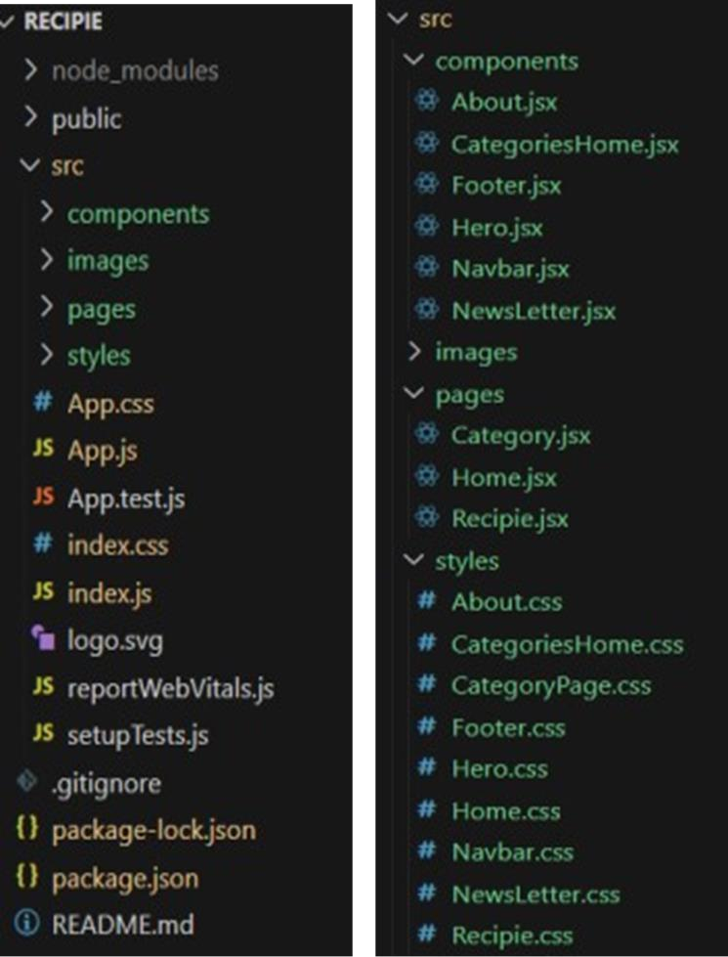

In this project, we’ve split the files into 3 major folders, *Components, Pages and Styles.* In the pages folder, we store the files that acts as pages at different url’s intheapplication.Thecomponentsfolderstoresallthefiles,thatreturnsthesmall

components in the application.All the styling css files will be stored in the stylesfolder.

# LANGUAGEUSED:

Hypertext Markup Language (HTML) is the industry-standard markup language fordeveloping web apps and pages. It is one of three foundational technologies underpinning the World Wide Web, along with JavaScript and Cascading Style Sheets (CSS). HTML documents are downloaded from a web server or local storage by web browsers, who then turn them into multimedia web pages. HTMLoriginally featured cues for the document's designandsemantically explainsthestructureof awebpage.The foundationofHTMLpages are HTML components. Images and other objects, like interactive forms, may be embedded within the produced page using HTMLtechniques. By indicating structural semantics fortext elements like headings, paragraphs, lists, links, quotations, and other objects, HTMLoffers a way to generate structured texts.

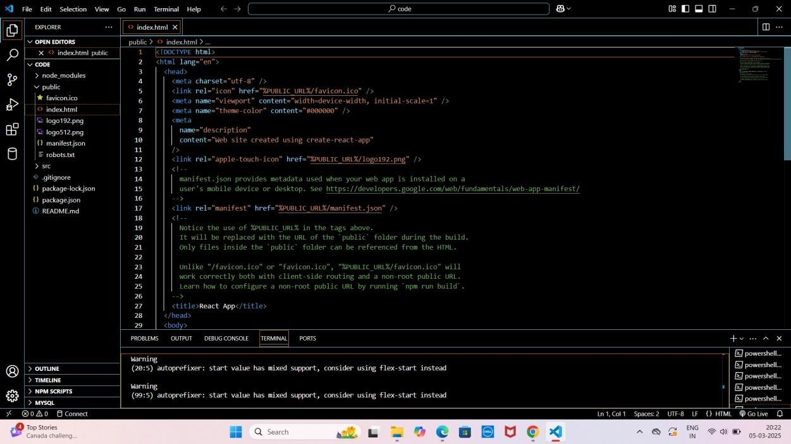

CascadingStyleSheets(CSS)isalanguageforcreatingstylesheetsthatdescribehow a document produced in a markup language like HTMLwill look. The World Wide Web's foundationaltechnologies,alongwithHTMLandJavaScript,includeCSS.Layout,color,and font may all be separated from content and presentation using CSS. By describing the pertinent 10 CSS in a separate CSS file, this separation can make content more accessible, give definition of presentation features greater freedom and control, allow numerous web pages to share formatting, and reduce complexity and repetition in structural content.

Visual Studio Code (VS Code) can be effectively used for writing project documentationduetoitspowerfultexteditingfeatures,built-inMarkdownsupport,anda wide range of extensions that allow for rich formatting, previewing, version control, and streamlined collaboration with developers.

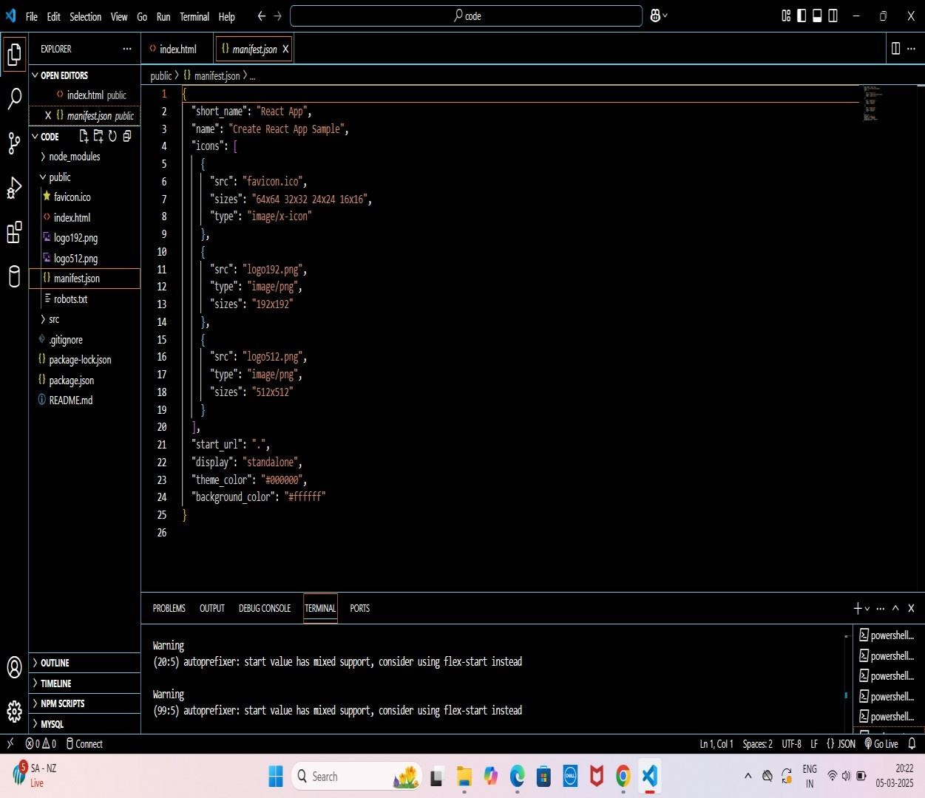

JavaScript often abbreviated as JS, is an interpreted, high-level programming language.Additionally,itisadynamic,weaklytyped,prototype-based,andmulti-paradigm language.OneofthethreefundamentaltechnologiesoftheWorldWideWeb,togetherwith HTML and CSS, is JavaScript. JavaScript is a crucial component of online applications because it makes web pages interactive. The vast majority of websites make use of it, and every significant web browser has an engine specifically designed to run JavaScript.

## UserInterfacesnips:

* + HerocomponentsTheherocomponentoftheapplicationprovidesabrief description about our application and a button to view more recipes.
  + PopularcategoriesThiscomponentcontainsallthepopularcategoriesofrecipes.
  + TrendingDishesThiscomponentcontainssomeofthetrendingdishesinthis application.
  + NewsLetterThenewslettercomponentprovidesanemailinputtosubscribefor the recipe newsletters.
  + CategorydishespageThecategorypagecontainsthelistofdishesunderacertain category.
  + RecipepageTheimagesprovidedbelowshowstherecipepage,thatincludes images.

## KnownIssues

Common issues with cookbooks include: inaccurate ingredient measurements, vague instructions,typographical errors,recipesnot beingtestedthoroughly,overly complex recipes for the average cook, lack of substitution suggestions, reliance on specialized ingredients that might be hard to find, recipes tailored to the author's taste rather than considering diverse preferences, and potential for dangerous ingredient combinations due to errors; ultimately, some recipes might not turn out as intended due to these inconsistencies

## Futureenhancement

Future enhancements for a cookbook project could include integrating AI-powered recipe generation, personalized dietary recommendations, augmented reality cooking guides, voice- activated instructions, social sharing features, advanced search capabilities, dietary restriction filtering,integrationwithsmartkitchenappliances,andacommunity-drivenrecipecontribution platform, allowing users to not only access recipes but actively participate in building the cookbook's content.

AI-poweredrecipegeneration:

* Usersinputdesiredingredientsordietaryneeds,andAIgeneratesuniquerecipesbased on available ingredients and user preferences.
* Abilitytocustomizerecipesbyadjustingflavors,spicelevels,orportionsizes with AI assistance.

Personalizeddietary recommendations:

* Users can input dietary restrictions (vegan, gluten-free, etc.) and the app filters recipes accordingly.
* Personalized meal plans based on dietary goal sand nutritional needs.

THANK YOU